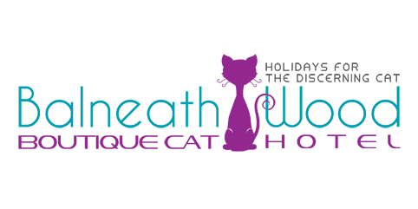

I Wish to board my Cat
from (date) …………………………………………
To collection (date) ………………………………

Owner’s Particulars
Surname ……………………………………..
First Name(s) ……………………………………………...
Address ……………………………………………………
……………………………………………………..
……………………………………………………...
………………………………………………………
Contact Telephone Numbers
Home ……………………………………………………...
Work ……………………………………………………
Mobile …………………………………………………….
Other (please specify) ……………………………………….
Email address ……………………………………………..

Your Cat’s Particulars
Name ……………………………………………………
Breed/Description ………………………………………….
Male/Female ……….. Age ……….
Does your Cat have a microchip or tattoo, if so what is the Identification number? ……………………………………...
Castrated/Spayed …………………………………………..
Current flea & tick prevention treatment ……………………

Any medical problems/conditions …………………………
……………………………………………………………
……………………………………………………………
What do you feed your Cat…………………………………..
Quantity …………………… Time(s) ……………………...

What sort of physical touch does your Cat enjoy (e.g. gentle caressing )
………………………………………………………………………………………………………………………………………………………………………………
And where (e.g. top of head, back, tummy etc) …………………..
………………………………………………………………………………………
What is your Cat’s favourite game: …………………………...
………………………………………………………………………………………
What is your Cat’s favourite toy: ……………………………..
………………………………………………………………………………………
What are your Cat favourite treats ……………………………………………………………………………………………………

Name and Address of your Veterinary Surgery
……………………………………………………………
……………………………………………………………
……………………………………………………………
Phone: ……………………………………

Please make Cheques payable to Balneath wood Cat Hotel
Contact us for credit card or bank transfer payments
Balneath Wood Cat Hotel
Balneath farm
South Chailey
Lewes
East Sussex
BN8 4AP

Balneath Wood Cat Hotel Terms & Conditions

Opening Hours:
- Monday – Thursday 9-10.30 and 4-5.30
- Friday 9-10.30 and 5-7
- Saturday 9-11
- We are closed Sundays and bank holidays
Deposit & Days Charged
Day of arrival, day of departure and all days booked are charged for - as we do not ask you to vacate by a certain time.
Payment in full is required at time of check-in. Payment facilities are provided for debit and credit cards and cash or cheques are accepted.
A non-refundable deposit of £50 will be charged to secure your reservation and will be deducted from the final bill.
We require fourteen days notice in the event of a cancellation.
Cancellations with less than fourteen days notice will incur the full charge and balance to be paid. If the suite can be rebooked, a partial refund may be offered at our discretion.
Health
A condition of boarding is that your pet is in a fit and healthy condition and has proof of vaccination. If however your pet falls ill whilst with us s/he will be covered by our insurance up to the policy maximum. Animals are boarded at the sole risk of their owners and whilst every care will be taken, the management cannot be liable for illness, injury or death of any animal in their care. If your pet falls ill after leaving the cattery and has sought veterinary attention within 72 hours of leaving, please let us know as you may still be covered by our veterinary insurance.
Checking In
All pets details are logged including any special needs, vets details, medication and dietary requirements. All pets must be fully vaccinated and hold a valid certificate that must be presented on arrival as a condition of residence.

